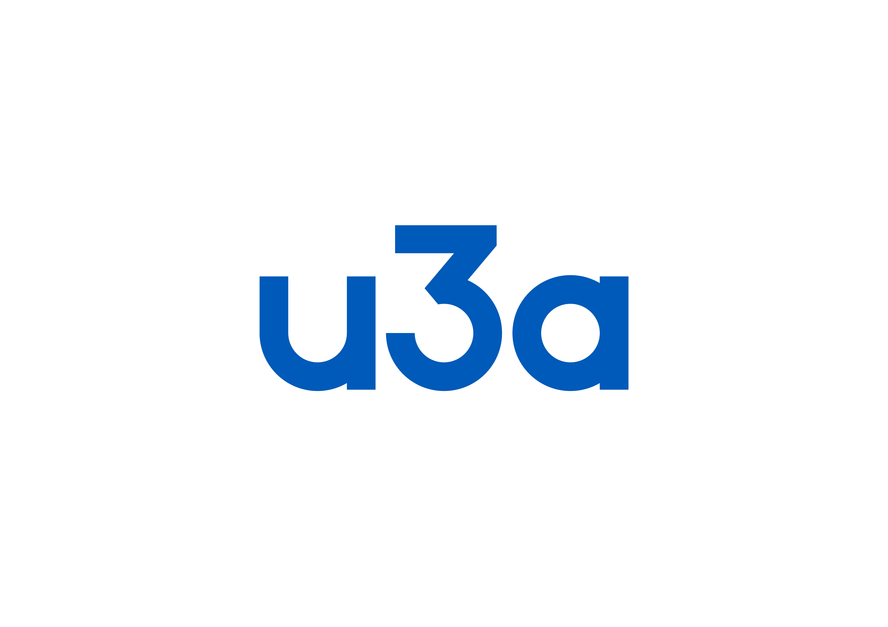
Membership Application Form
Isle of Man
Name: _____________________________________________________
Address: _____________________________________________________
______________________________________________________
Post Code: _____________________________________________________
Phone – landline/mobile: _________________________________________
Email: _____________________________________________________
Data Protection Act: We collate your contact details to maintain our membership list, keep in touch with you and send you AGM papers, newsletters, etc, as part of our obligation to you as a member. We will not share your details with anyone else, except if you have elected to receive the TAM magazine when u3a National Office is provided with your name and address.
We will keep your data only for the duration of your membership. Should we not be able to contact you after renewal time, we will remove you from the database. If you wish to complain, cancel your membership or unsubscribe, please email the Membership Secretary through our website, or write to the address below.
Photos: Photographs may be taken at Network or Group meetings and subsequently used for publicity purposes. Please make it known at the time if you do not wish to appear on the photo.
- u3a (IOM) is an autonomous organisation and membership does NOT give membership of any other u3a although you may be able to be a temporary member if you are visiting the area. Please contact the UK u3a group leader to discuss.
- The membership year is 1st April to 31st March, and the annual subscription is £20.00
- Please note: an amount is paid to the Third Age Trust out of every subscription to cover insurance, services and the Third Age Matters (TAM) magazine.
- I agree to abide by the Constitution and Rules of the u3a (IOM).
- In certain study groups, personal information may be disclosed in confidence. I undertake to respect such confidential personal information.
- I agree for the u3a (IOM) to hold my details as above for the time I am a member.
Signed: ______________________________________Date_______________________
Bank details: The University of the Third Age (Isle of Man)
Sort Code: 40-19-38 Account No: 94131932
Payment ref: your first name and surname
If your bank system gives you the options of Personal or Business, choose Business
If paying by cheque, please make your cheque payable to “The University of the Third Age (IOM)” and return it with this completed form to our Registered Office:
The Treasurer u3a IOM, c/o St John’s Mill, St John's Mill, Mill Road, St Johns, IM4 3AF
(Please note that the postage is now 90p.)

Isle of Man Registered Charity No: 1121 Web: https://isle-of-man.u3asite.uk

