Registering to use the Portal
The first time you access the Portal you will need to register as follows:
- Before you start make sure you have your membership number to hand - it is shown on your Membership Card, or contact your Membership Secretary. Your u3a should have provided a link to access the Members Portal sign-in page (probably on your u3a website or in an email to members). Enter your email address and press Confirm Identity:
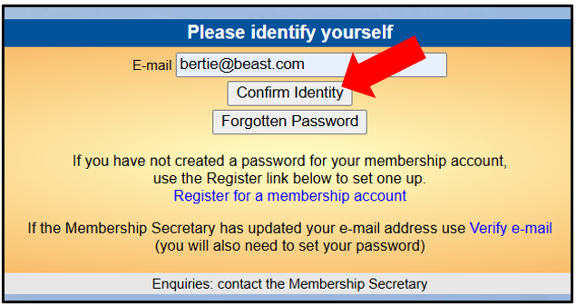
If you email address does not match that held on your u3a's records, you will be asked to check your email address and try again:
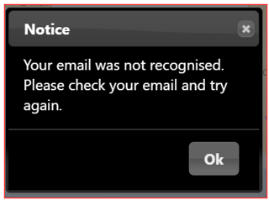
If your email address is still not recognised you will need to contact your Membership Secretary to check the email address held on the system.
If your email address is shared with another u3a member who has previously registered for an account, refer to section c) below.
- Type in your Membership number, Forename (or Familiar Name), Surname, Post Code and Email Address, then press Confirm Identity: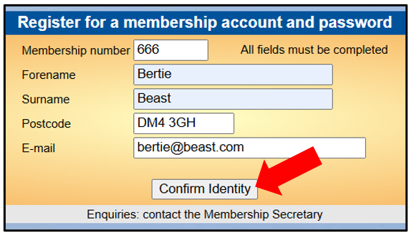
Note: The details entered have to exactly match those held by your u3a, otherwise you will be prompted to try again or contact your Membership Secretary:
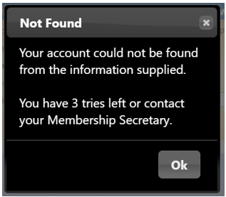
After correctly entering the required 5 pieces of data you will be asked to create a password of between 10 and 72 characters including at least one upper case, one lower case and one numeric character. Enter your password in the 2 boxes and press Update Account:
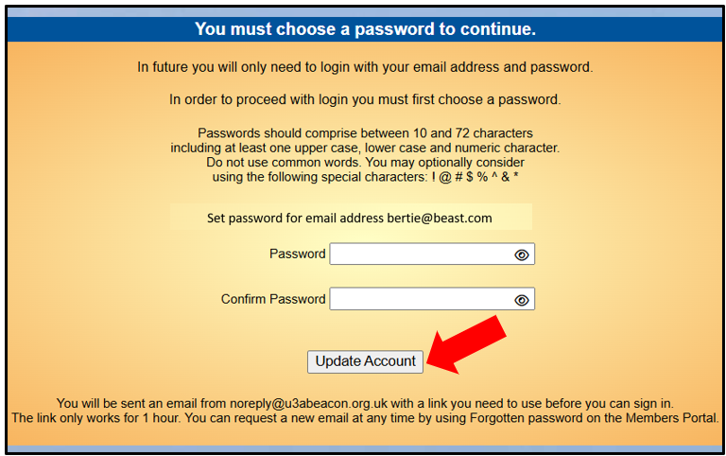
- You will see the following screen confirming that you have been sent an email with a link and that you can close this browser window because clicking the link in the email will open a new browser: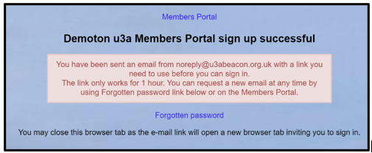
If the email doesn't arrive within a few minutes, check your Spam folder.
Note: The confirmation email will expire after 1 hour, although you can return to the Members Portal sign-in page and press Forgotten Password to request a new confirmation email.
- After clicking the link in the email, enter your password and press Confirm Identity: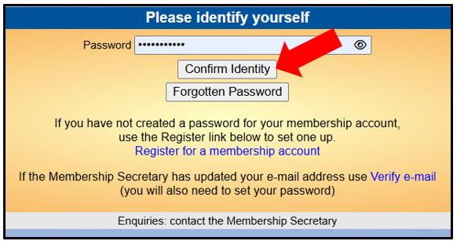
If the details that you entered do not match those held on the system, you will be prompted to use the Forgotten Password link or to contact your Membership Secretary: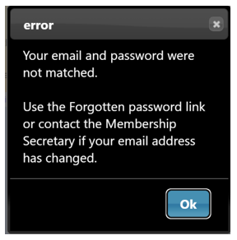
Note that your Membership Secretary can neither see nor set your password.
- After a successful sign-in you will be taken to the Members Portal Home page. The menu choices that you see on the Home screen may vary depending on which options your u3a has enabled.:
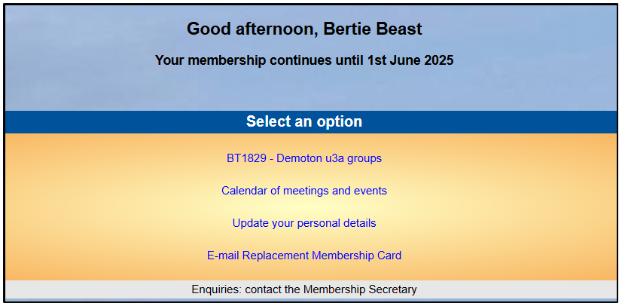

c) Members that share an Email Address & Password
Shared email address
When 2 members share an email address, the 1st member may register as described in section b)above. However, when the 2nd member wishes to register, they must click the Register for a membership account link rather than pressing the Confirm Identity button:
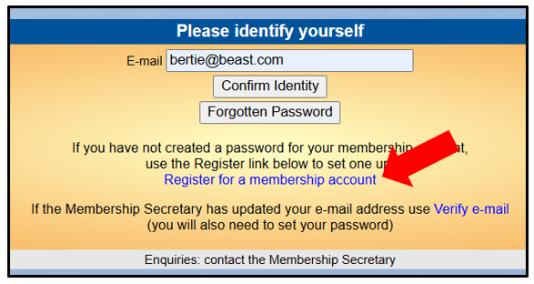
After that the registration process continues as described in section b) above.
Shared password
When 2 registered members share an email address and use the same password, they will be asked to identify which member is signing in by selecting from a drop-down list:
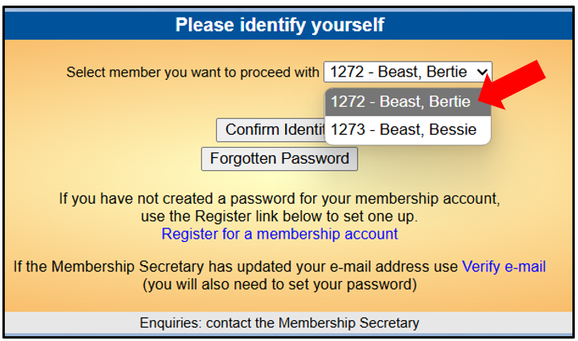
Note: it is not good practice to share a password from a security point of view, so it is recommended that members use different passwords when registering to use the Members Portal.

